**1. Write a c program t evaluate the code for breadth first search (BFS)**

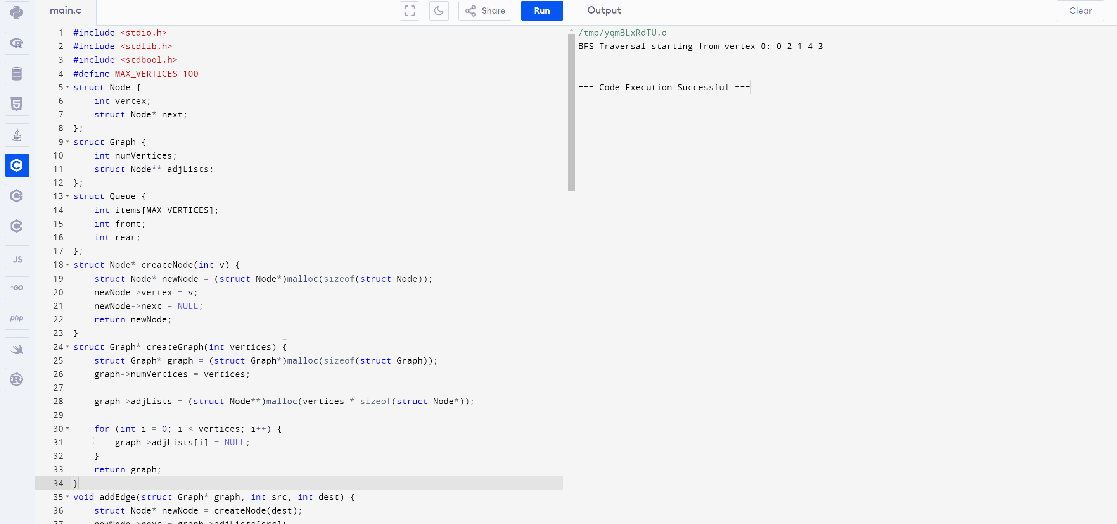

**2.Write a c program to evaluate the code for depth first search (DFS)**

